**Capstone Project - The Battle of the Neighborhoods**

**Applied Data Science by IBM/Coursera**

**Introduction**

**Background - Optimal neighborhoods for new comers**

London is the capital of UK, which attracts immigration from both domestic and international. In 2018/19, there were more than 340 thousands of immigration moving into London. New immigration family always find themselves struggling in finding the best spot for their family.

**Relocation Problem**

In this project, we aim to solve for the optimal location for a family which is new to a city. Specifically, this report will be targeted to expats or immigrants interested in moving into **London**, UK.

Since every family has their unique characteristic and needs, some basic assumptions on family composition and their preference are needed to be made. Out of all basic needs, education usually is the most critical for home location, since proximity is the determining factor for school admission. Neighborhoods with sufficient education institutes for children will be ranked by its **proximity to the city center** as it will be more convenient for the parents to commute to work.

Once gathering related data from various sources, a data science model will be built to specify few most suitable neighbourhoods based on this criteria. Advantages of each area will then be clearly expressed so that best possible final location can be chosen by the new family.

**Data**

Based on definition of our problem, factors that will influence our decision are:

* number of schools in the neighborhood (any type of schools)
* number of schools for young kids in the neighborhood
* distance of neighborhood from city center

We decided to use regularly spaced grid of locations, centered around city center, to define our neighborhoods.

Following data sources will be needed to extract/generate the required information:

* centers of candidate areas will be generated algorithmically and approximate addresses of centers of those areas will be obtained using **geocoder package in geopy**
* number of schools and location in every neighborhood will be obtained using **Foursquare API**
* coordinate of London center will be obtained using **geocoder classes in geopy** of the Trafalgar Square, a well known landmark in central London.
* 364 candidate neighborhood centers generated for our analysis

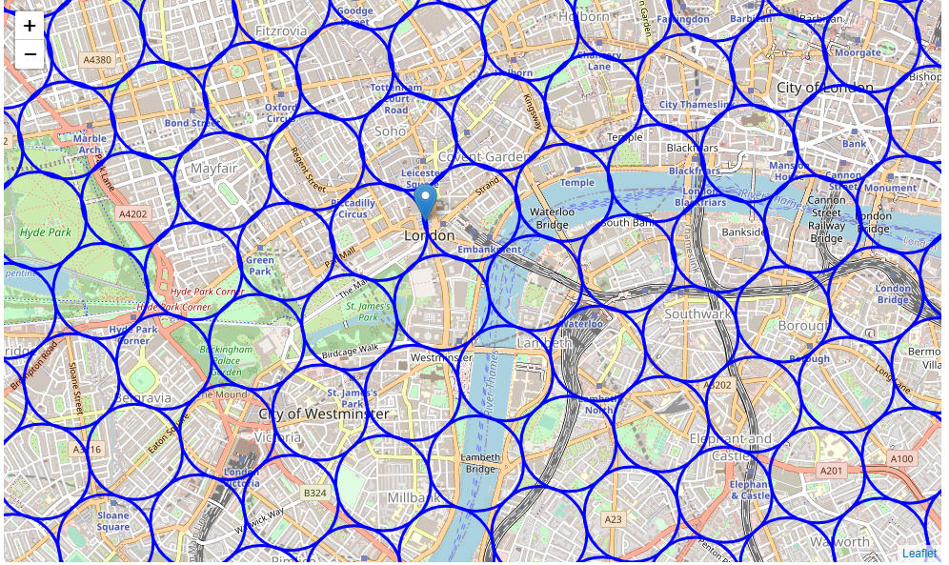

**Foursquare**

Now that we have our location candidates, let's use Foursquare API to get info on restaurants in each neighborhood.

We're interested in venues in 'school' category, but only those that are schools for kids. business school or driving school etc. are not institutes for children so we don't care about those. So we will include in out list only venues that have 'schools' in category name, We have define a subset of schools for young children, including pre-school, nursery, primary and junior school. We'll make sure to detect and include all the subcategories of specific 'children school' category, as we need info on school for young children in the neighborhood. Here’s the information generated from Foursquare:

Total number of schools: 122

Total number of Children schools: 25

Percentage of Children schools: 20.49%

Average number of schools in neighborhood: 7.107142857142857

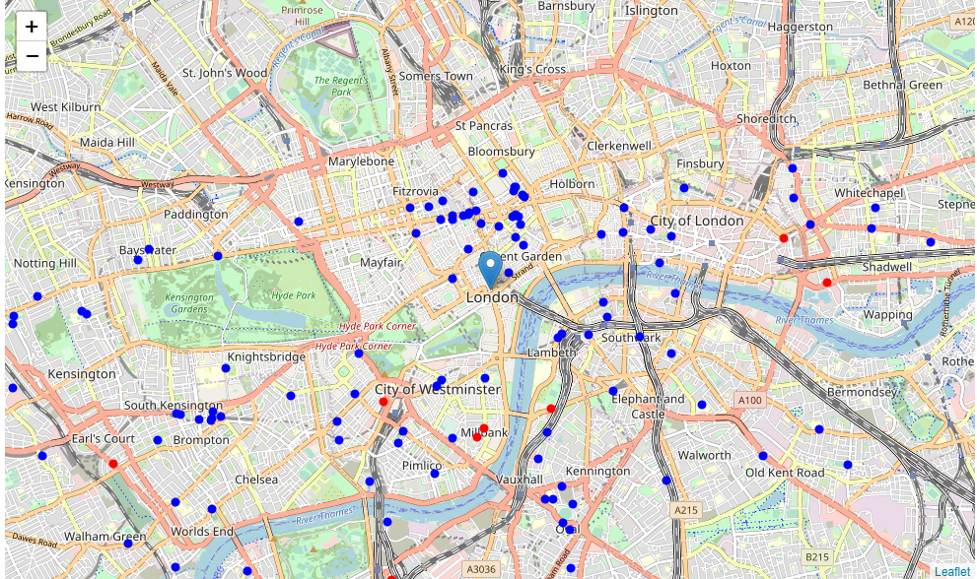

**Methodology**

In this project we will direct our efforts on detecting areas of London that have high density of schools, particularly those are high with school for young kids. We will limit our analysis to area ~6km around city center.

In first step we have collected the required **data: location and type (category) of every school within 6km from London city center** (Trafalgar Square). We have also built a list of **identified schools for young children** from the Foursquare categorization.

Second step in our analysis will be calculation and exploration of '**density of schools**' across different areas of London - we will use **heatmaps** to identify a few promising areas close to center with many schools for selection *and* especailly schools for young children and focus our attention on those areas.

In third and final step we will focus on most promising areas and within those create **clusters of locations that meet some basic requirements** established in discussion with stakeholders: we will take into consideration locations with **a school for children in radius of 500 meters**, and we want locations **more than three schools in radius of 1000 meters**. We will present map of all such locations but also create clusters (using **k-means clustering**) of those locations to identify general zones / neighborhoods / addresses which should be a starting point for final 'street level' exploration and search for optimal venue location by stakeholders.

**Analysis**

In the following section, we will perform some basic explanatory data analysis to have a better understanding from our raw data. First let's count the number of schools in every area candidate. The average number of schools in every area with radius of 1000m is 7.1

Then we will calculate the distance to nearest school for young children from every area candidate center. And the average distance for a children school from area center is around 1.1km. This information will be used when applying filter for our areas.

Next we will create a map showing heatmap / density of schools to analyse the various neighborhoods. Also, it will show **borders of London boroughs** on our map with a few circles indicating distance of 1km, 2km and 3km from Trafalgar square.

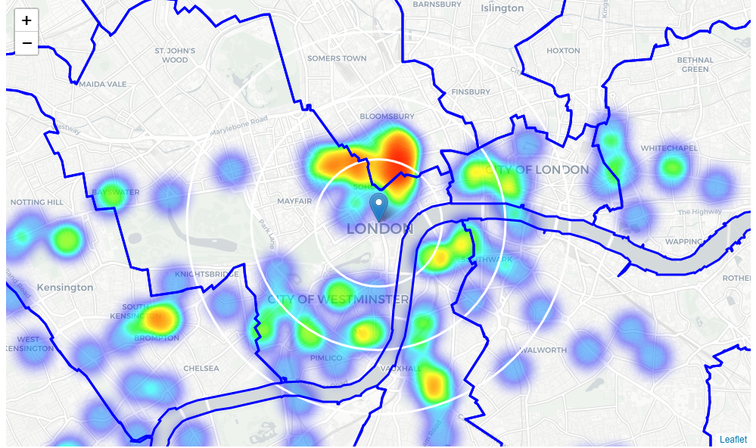From the heatmap, we can locate several areas with cluster of schools in central London near Holborn, Notting Hill, Victoria, Waterloo and Whitechapel.

Let's create another heatmap map showing heatmap/density of Children Schools only.

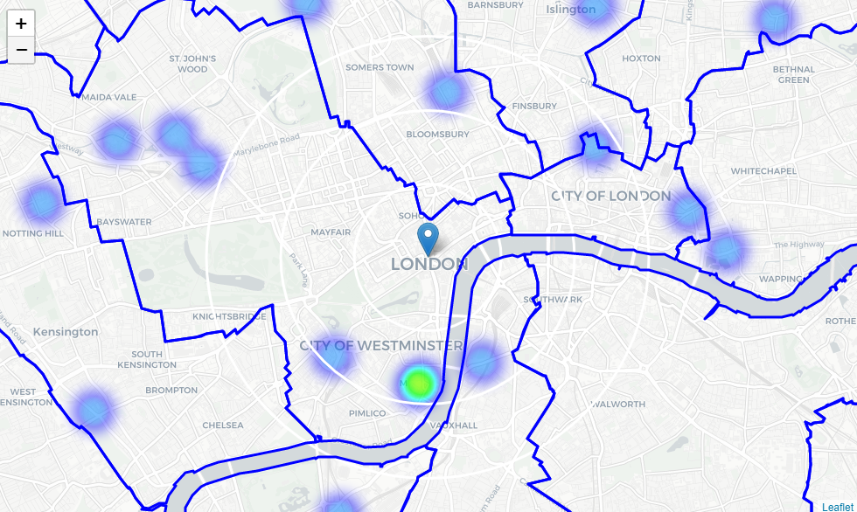

Since schools for children only represent 20% of all schools in London, therefore they are shown as less concentrate in the map above. Even though central London has a high density of schools, however, not many schools for children are located in central London. Therefore, our area of interest will shift towards the west side of central London.

These clusters are in Islington on the north east, Notting Hill on the west, Victoria on the south, Whitechapel on the east of the Trafalgar Square. Given Notting Hill and Victora both show some "heat" for schools and children schools. We will move focus on a radius of 3km within these two areas and let them become the center of our area of interest.

**Notting Hill and Victoria**

Analysis of popular guides and web sites for expats and newcomers to London often mention Notting Hill and Victoria as interesting and family-friendly London neighborhoods popular with expats as well as Londoners.

*"The district adjoins two large public parks, Holland Park and Kensington Gardens, with Hyde Park within 1 mile (1.6 km) to the east."* (wikipedia.org)

*"Famous for its eponymous movie with Julia Roberts and Hugh Grant, Notting Hill is a beautiful neighborhood replete with cute shops, restaurants and colorful Victorian townhouses. It is also famous for the Notting Hill Carnival, a tradition tied to its vibrant Caribbean heritage. It is also centrally located in West London."* (expatexchange.com)

*"Notting Hill is also really popular for it’s central location, beautiful homes, and private gardens"* (onyxpropertyteam.com)

*"Victoria is as central as you can be with the amazing Georges Square Park just a few minutes away. Lovely walks and beautiful buildings. I feel at home and westminster council embrace you like a family would. Amazing surroundings, culture and tourist spots keeps it interesting"* (foxtons.co.uk)

*"Victoria is the main gateway to London for visitors flying into Gatwick Airport. The neighbourhood revolves around Victoria train station, London's second busiest after Waterloo, with Victoria underground station just beneath the railway station."* (londontoolkit.com)

Areas near Notting Hill and Victoria are both popular with expats, close to city center and well connected; those boroughs appear to justify further analysis.

Let's define new, narrower region of interest, which will include high-school-count parts of Notting Hill and Victoria closest to London City Centre.

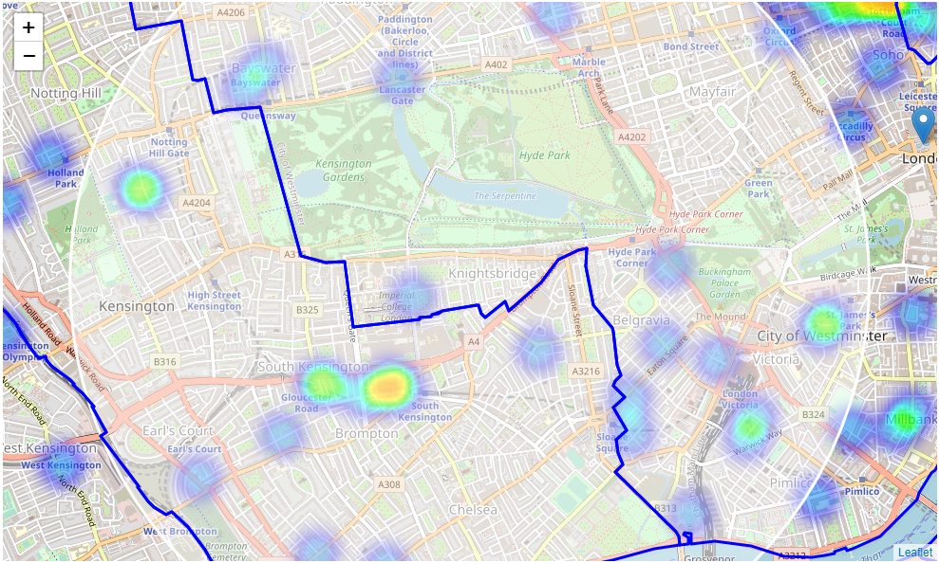

This map has covered one of the schools cluster in the west London and it's good for family as Hyde Park is right at the centre of this area.

Then we create more dense grid of location candidates restricted to our new region of interest (let's make our location candidates 100m apart) and apply a **filter** those locations. We're interested only in **locations with more than two schools in radius of 250 meters**, and **school for children in radius of 400 meters**.

Locations with more than two schools nearby: 111

Locations with children school within 400m: 127

Locations with both conditions met: 6

Let's see how this looks on a map.

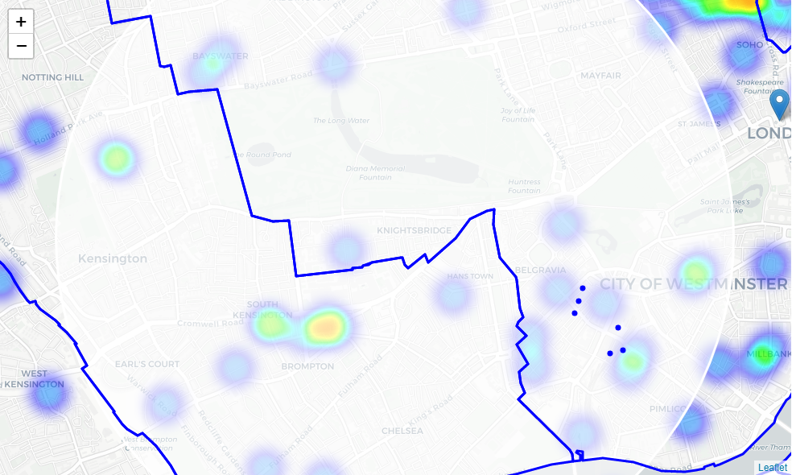

We now have a bunch of locations fairly close to City Centre (mostly in Victoria within the City of Westminster), and we know that each of those locations has more than two schools in radius of 250m, and has a school for children within 400m. Any of those locations is a potential candidate for our new expat family to London.

Let's now show those good locations in a form of heatmap:

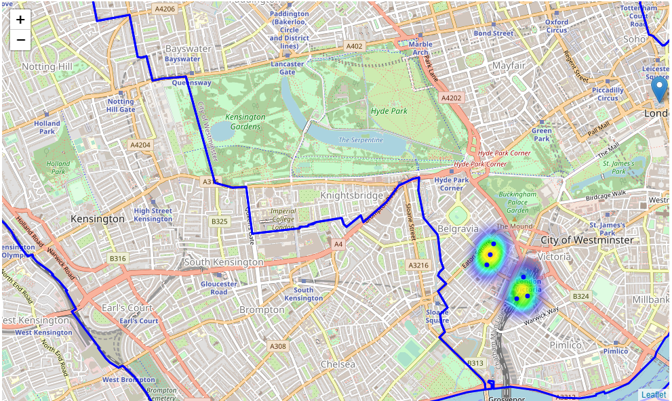The map above show a clear indication of zones with some schools within that area and schools for children in walking distance.

Let us now **cluster** those locations to create **centers of zones containing good locations**. Those zones, their centers and addresses will be the final result of our analysis.

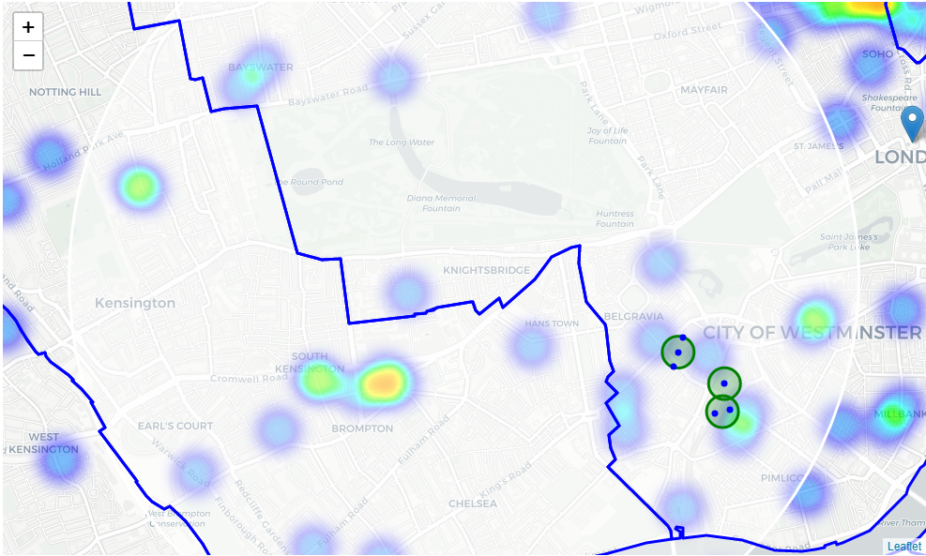

Our clusters represent groupings of most of the candidate locations and cluster centers are placed nicely in the middle of the zones 'rich' with location candidates.

Addresses of those cluster centers will be a good starting point for exploring the neighborhoods to find the best possible location based on neighborhood specifics.

Let's see those zones on a city map without heatmap, using shaded areas to indicate our clusters:

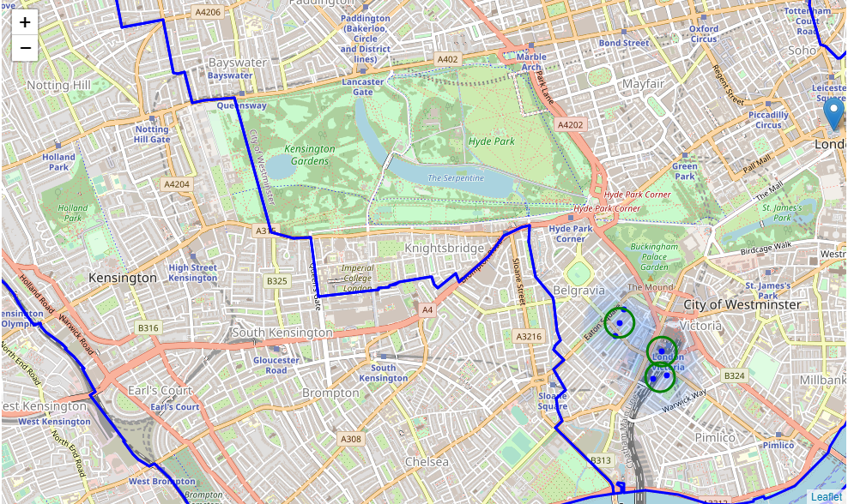 Let's zoom in on candidate areas in **Victoria**:

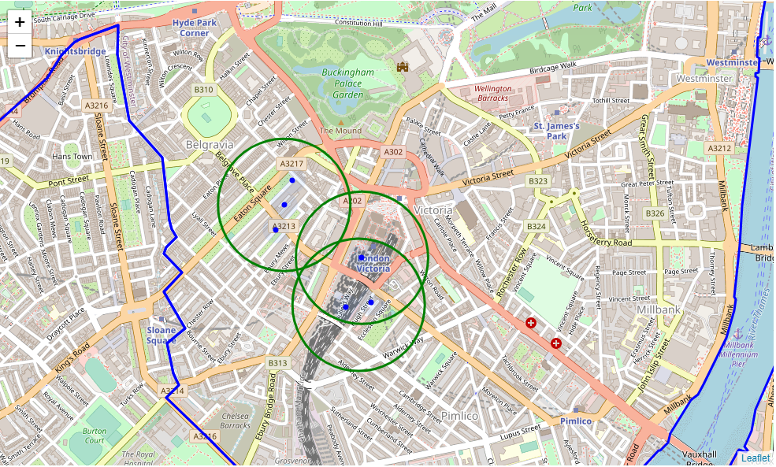

Checking the distance to city centre by using **reverse geocode those candidate area centers to get the addresses**.

==============================================================

Addresses of centers of areas recommended for further analysis

==============================================================

Eaton Mews South, Belgravia, City of Westminster, London, SW1 => 2.0km from Trafalgar Square

1, Eccleston Bridge, Victoria, City of Westminster, London, SW1V 1QD => 2.1km from Trafalgar Square

14, Eccleston Bridge, Victoria, City of Westminster, London, SW1V 1QD => 2.0km from Trafalgar Square

This concludes our analysis. We have created 3 addresses representing centers of zones containing locations with schools nearby and children schools within walking distance, while all 3 addresses are 2km away from the city center. All of these addresses are located in near Victoria station within City of Westminster, which is very convenient to travel around the city no matter where the offices of the expat are.

**Results and Discussion**

In order to find the most suitable neighbborhood in London for the expat family who's new to the City. Out of all the schools information available in foursquare, we primarily focus on the location data for schools that serve the younger kids, e.g. nusery, kindergarten, junior and primary schools. After applying the heatmap analysis on the area around central London, we found that few areas with relatively higher concentration of these schools for children. From the heatmap we generated, we've located several areas with cluster of schools in central london near Holborn, Notting Hill, Victoria, Waterloo and Whitechapel. Finally, we found that Notting hill and Victoria are the areas closest to city centre with decent number of schools for children available.

After directing our attention to this more narrow area of interest, we first created a dense grid of location candidates (spaced 100m appart); those locations were then filtered so that those with more than two schools in radius of 250m and those with schools for childern closer than 400m were included. And then we use reverse geocoding to retrieve the address for these centers.

Even though we have formed 3 clusters within the area of Victoria in the final analysis, these areas are the potential best solution for the new familie to London based on our assumptions. It doesn't mean that this clusters are the optimial locations for everyone. However, we do believe it would be a good starting point as well as a benchmark for those who have no idea to select their first home in London.

**Conclusion**

In this project, we aim to solve for the optimal location for a family which is new to a city. Specifically, this report will be targeted to expats or immigrants interested in moving into **London**, UK. We targeted the neighborhoods with sufficient education institutes for children and then ranked by its **proximity to the city center** as it will be more convenient for the parents to commute to work.

By using location data from Foursquare and building our data science model to analyse the data. Advantages of each area are clearly expressed and we have identified a few locations suitable to the new families. The final part of the project has narrowed down to 2 neighborhoods, i.e. Notting Hill and Victoria. And we have suggested 3 clusters which are closer to the city centre and with sufficient schools available for those new families moving into London.